

SUPERIOR UNIVERSITY LAHORE
GOLD CAMPUS

NAME: MUHAMMAD MOIZ RAZA
ROLL NO: SU92-BSAIM-F24-061
PROGRAM: ARTIFICIAL INTELLIGENCE
SEMESTER: 3rd SEMESTER
SECTION: BSAI-3A
SUBJECT: ARTIFICIAL INTELLIGENCE

Submission Title: LAB TASK- 11
- Data Processing
- Dealing with Null Values
- Changing Datatypes of Columns to be "Int"
- Train test Splitting
- Choose and apply the right model
- Testing/Predicting
- Display Accuracy Score
- FLASK APP
Submitted To: Sir RASHIK ALI

LAB TASK-12
TASK:
DATA PREPROCESSING
Train test Splitting
Choose and apply the right model
Testing/Predicting
Display Accuracy Score
Flask app

Dataset Used
CSV : BMW sales data (2010-2024).csv
Rows: 50,000 rows
Columns: 11 features

Operations Performed:

Data Loading
- import pandas as pd: Imported pandas library for data analysis and manipulation
- pd.read.csv(): Loaded the CSV file into a pandas DataFrame

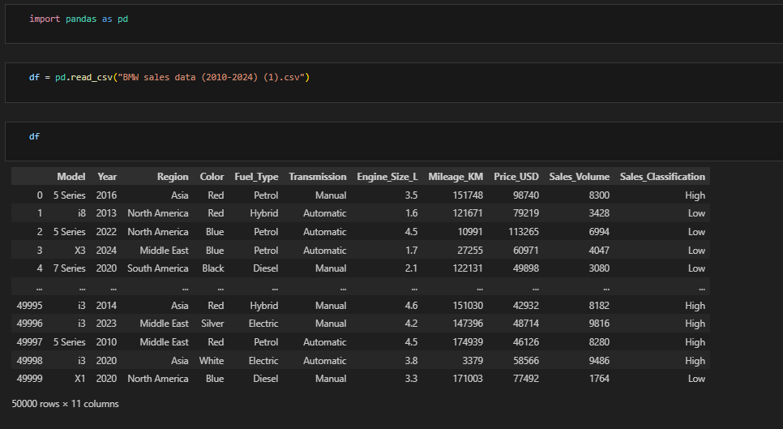

Data Exploration
- df : Displayed the entire dataset to see all 50,000 records
- df.shape :Checked the dimensions of dataset (50,000 rows × 11 columns)
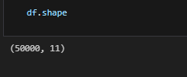
- df.head(20): Viewed first 20 records to understand data structure
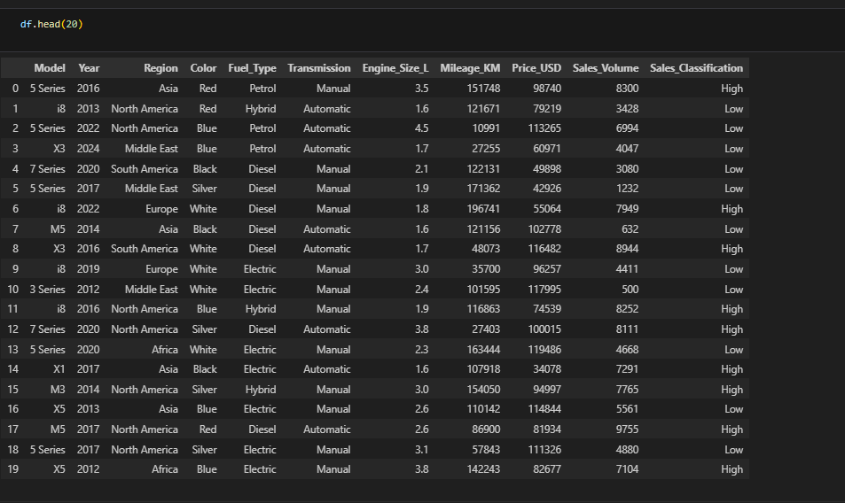
- df.tail(10) : Checked last 10 records for data consistency
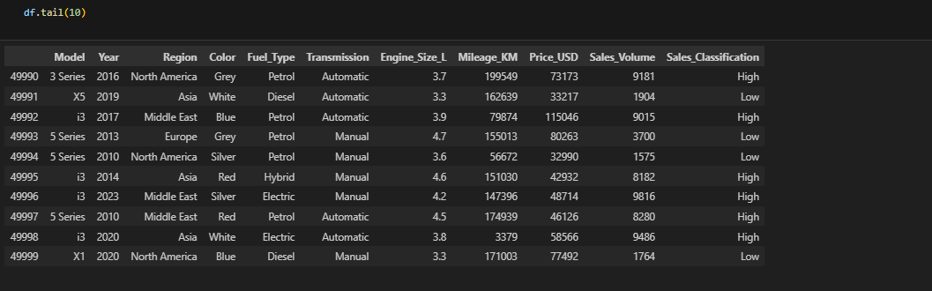

Data Cleaning

- df.dropna() - Applied function to remove null values
- inplace=True - Saved changes directly to the original DataFrame

Dealing with Null Values
In this part of the lab task, missing or null values in the dataset were identified and handled properly. Null values can affect the accuracy of analysis, so they must be cleaned before further processing.
1. The command `df.isnull().sum()` was used to check how many null values were present in each column.
2. Rows containing null values were viewed using `df[df['Year'].isnull()]`.
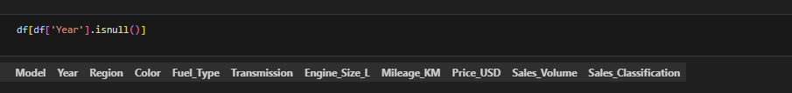
3. All rows having missing data were removed using `df.dropna(inplace=True)`, ensuring that the dataset became clean and complete.
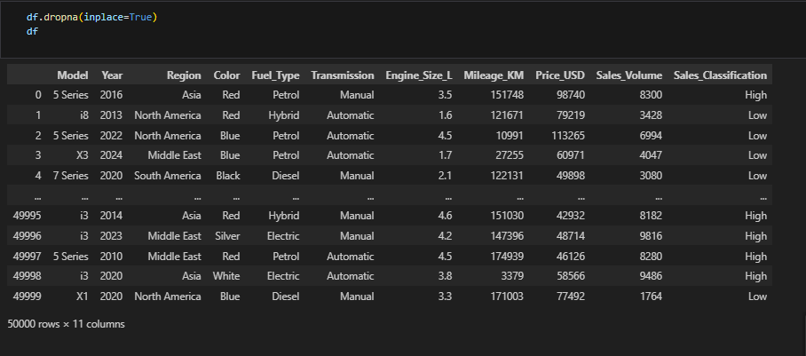
4. For categorical columns such as **Region**, **Model**, and **Transmission**, missing values were filled with the most frequent value (mode) using a function with the command `fillna(df[i].mode()[0])`. This ensured that no blank spaces remained in these columns.

Changing Datatypes of Columns to be “Int”
After handling missing values, the next step was to ensure that all data columns had appropriate data types. The column **Price_USD** originally contained float values. To make the data more consistent and suitable for numerical operations, its datatype was converted to integer using the command `df['Price_USD'] = df['Price_USD'].astype('int64')`.

Converting to integer type helps in reducing memory usage and makes the dataset ready for tasks such as grouping, comparison, and statistical analysis. This ensures that the data is properly structured and reliable for further study.
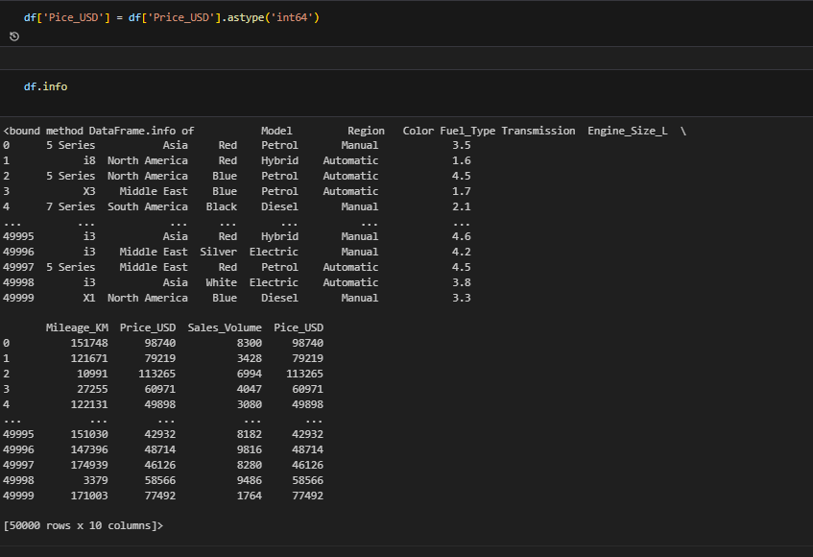

Train-Test Splitting
I divided the dataset into training and testing parts. The training data teaches the model, while the testing data checks how well the model performs on unseen information.

Model Selection
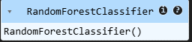
I selected the Random Forest Classifier because it gives strong accuracy, handles different data types well, and works best for classification tasks like predicting High or Low sales.

Testing / Predicting
After training the model, I used the test data to generate predictions. These predictions show how the model classifies the sales category.

Accuracy Score
I calculated the accuracy score by comparing the predictions with the real labels. This score tells how correctly the model performed overall. Accuracy is 1.0
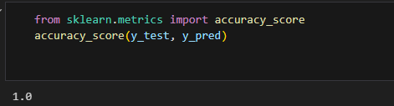

FRONTEND:
After train a model. Now we make a front end on flask with stylish look in which we enter our experience and interest then we get our recommended course for GUI we use flask.
STRUCTURE:
- app.py
- Template folder
- Index.html
- Result.html
- Static folder
- Style.css
- Script.js
- Requirements.txt
- Model_train.ipynb file
- Model.pkl
- Venv file

App.py: This is our main entry point of flask application
Templete/index.html: This is our home page of website
Templete/result.html: this is another page in which our predicted score shows
Style.css:This is my css file of Gui in which all style and theme of my Website Written
Requirement.txt: I this file our libraries which is use in our project is written it is use to install libraries in virtual env
Model_train.ipynb file: In this File we train our model from dataset
Model.pkl: In this file our trained model is saved.



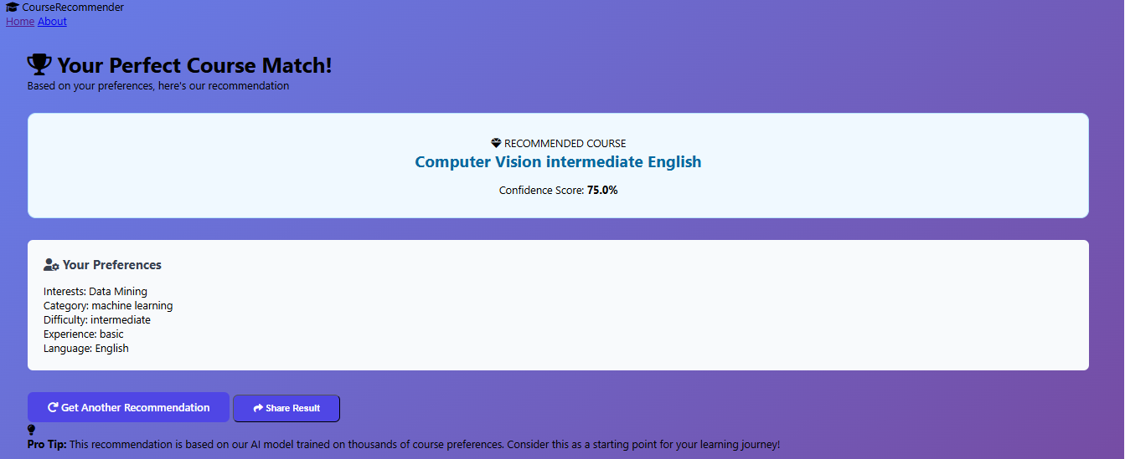

THE END

